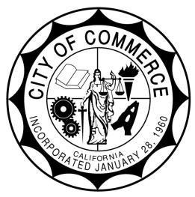
CITY OF COMMERCE
AGENDA REPORT

TO: Honorable City Council

FROM: City Manager

SUBJECT: Update on DTSC Exide Cleanup and Grass Planting

MEETING DATE: August 26, 2025

RECOMMENDATION:

It is recommended that the City Council receive and file an update on the Department of Toxic Substances Control (DTSC) Exide Cleanup and Parkway Restoration efforts.

BACKGROUND/ANALYSIS:

DTSC continues its remediation of lead-contaminated soil in residential parkways within the Bristow and Bandini neighborhoods. Following initial cleanup, many parkways were left with bare soil and hydroseed. However, the City received concerns that the parkways were not being properly maintained, resulting in poor grass growth and barren parkways.

In response, Staff worked with DTSC to identify a more sustainable approach to restoration. DTSC has now agreed to restore all parkways in-kind by replacing sod in areas that previously had established grass, while using hydroseed only in locations that were historically bare dirt or without grass.

FISCAL IMPACT:

There is no fiscal impact to the City.

ALTERNATIVES:

- Approve staff recommendation
- Disapprove staff recommendation
- Provide further direction to staff

RELATIONSHIP TO STRATEGIC GOALS:

This agenda item relates to the 2016 Strategic Plan, Infrastructure and Facilities

Guiding Principle 4:

Develop and invest in infrastructure and beautification projects that support economic growth.

Approved and Recommended by: Shahid Abbas, Director of Public Works
Fiscal Impact reviewed by: Alvaro Castellon, Director of Finance
Approved as to form by: Noel Tapia, City Attorney
Respectfully submitted: Ernie Hernandez, City Manager

