
CITY OF COMMERCE
AGENDA REPORT

Item No.

TO: Honorable City Council

FROM: City Manager

SUBJECT: A Resolution of the City Council of Commerce, California, Authorizing Approval of the Purchase of 25 New Replacement Bus Shelters and Accessories

Meeting Date: August 26, 2025

RECOMMENDATIONS:
- Approve the purchase of twenty-five (25) bus shelters and accessories (Model: 12’ Empire Transit Shelter) for transit operations in the amount of $610,657 through the MBTA/CALACT Procurement 21-01-10/24 cooperative purchase contract.

- Declare the surplus of existing equipment (25 shelters).

BACKGROUND:

The transportation department currently maintains fifty (50) bus shelters throughout the City of Commerce. These shelters facilitate travel on bus lines operated by the City of Commerce Transit, Montebello Bus Lines, and the Los Angeles County Metropolitan Transportation Agency. On March 15, 2024, transportation staff applied for and were awarded $712,770 through the Los Angeles County Metropolitan Transportation Authority Bus Operators Sub-Committee (BOS) Associated Transit Improvement (ATI) - FTA Section 5307 competitive grant funds.

ANALYSIS:

The new modern bus shelters will feature solar LED lighting for improved visibility and passenger safety, bus arrival time displays, display panels, backless seating, and trash receptacles. Transportation staff prioritized replacements based on ridership utilization and equitable disbursement throughout the City.

Tolar Manufacturing has provided a quote of $610,657 to complete Phase I, which involves purchasing twenty-five (25) new bus shelters to replace current, outdated shelters. Phase II shall be funded through the Metro regional bus shelter replacement program, which shall commence following the installation of Phase I and the signing of the required Memorandum of Understanding (MOU) between LA Metro and the City of Commerce.

PROPOSED BUS STOP SHELTER CURRENT BUS STOP SHELTER

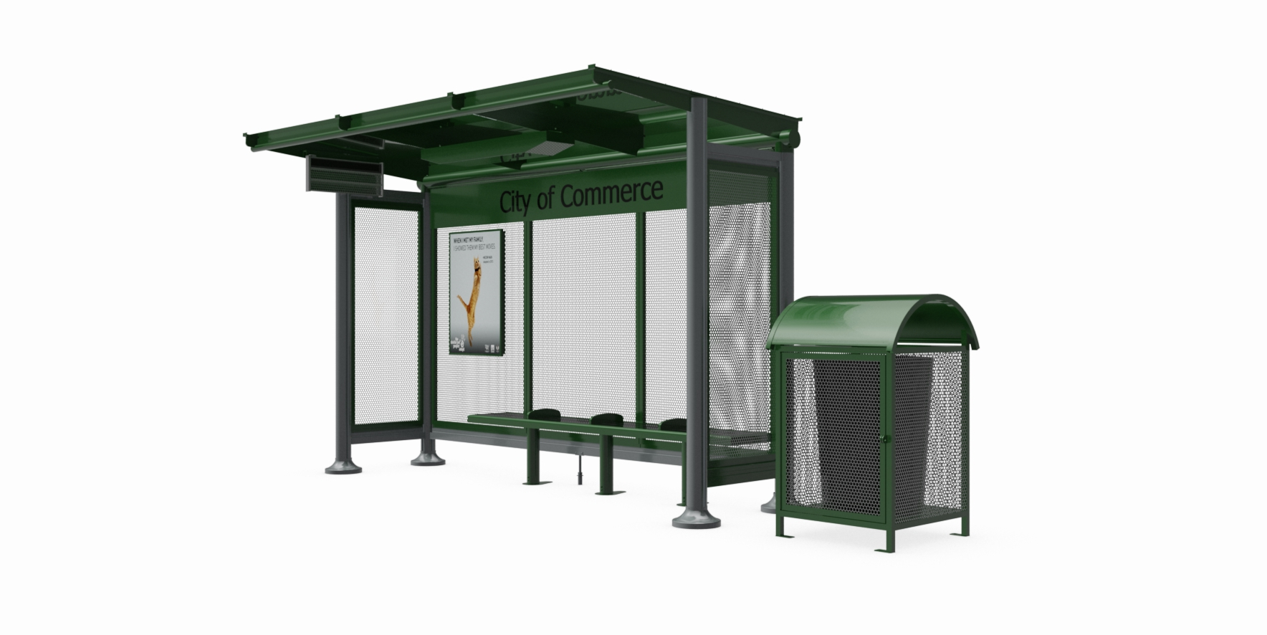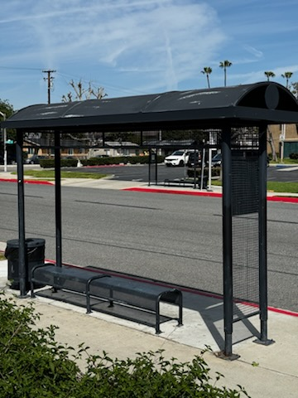

PHASE I - BUS SHELTER and amenIties replacement locationS

STREET LOCATION | CROSS STREET | DIRECTION | SHELTER QUANTITY
Commerce Center | Whittier | BUS LOADING AREA | 4
Commerce Way | Jillson | S/W | 2
Commerce Way | Jardine | N/E | 1
Greenwood | Gage | S/W | 1
Greenwood | Gage | N/E | 1
Garfield | Telegraph | N/E | 1
Garfield | Washington | N/E | 2
Garfield | Washington | S/W | 2
Triggs | Eastern | S/E | 1
Washington | Atlantic | N/W | 1
Washington | Fidelia | S/E | 1
Telegraph | Casino | N/E | 1
Telegraph | Citadel | N/W | 1
Harbor | Eastern (EB) | S/E | 1
Harbor | Eastern (WB) | SW | 1
Eastern | Slauson (NB) | N/E | 1
Eastern | Harbor | N/E | 2
Gage | Garfield | S/E | 1

The estimated cost for installation is separate and costs approximately $90,000. The scope of work needed to install and replace the current bus shelters will require a formal bidding process, which will be posted through PlanetBids. The work involves removing the existing bus shelters, repairing the sidewalk if necessary to meet ADA requirements, and installing the new bus shelter equipment and amenities.

AVAILABLE BRANDING OPTIONS

The proposed bus shelters offer branding options that could be integrated into the purchase packet at an additional cost. Bus shelter branding offers several options, including traditional static posters, illuminated panels, digital displays, and creative, custom-designed shelters.

A few examples are referenced below.

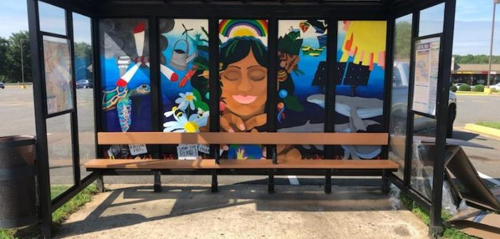

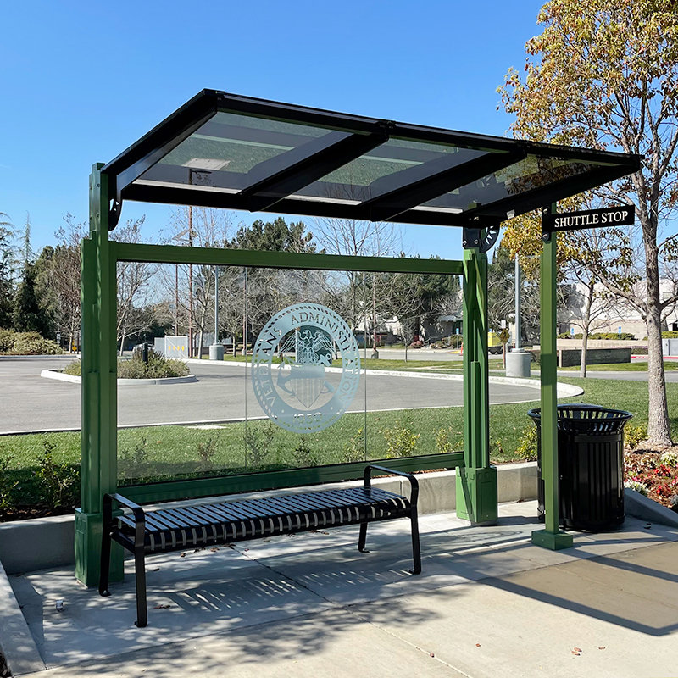

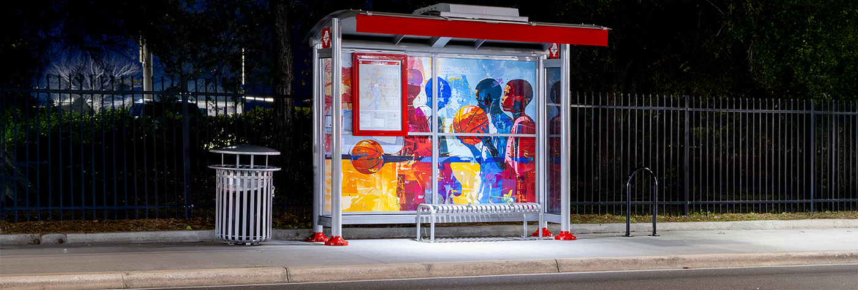

The cost of custom branding varies based on the artwork details. Typically, the price for custom glass is $7000 per shelter. The powered coat and perforated screens cost $ 3,000, and polycarbonate is included at no additional charge. The staff recommends that if custom branding options are preferred, we must identify another funding option to complete Phase I of the project.

fiscal impact:

The purchase will be accomplished through the Morongo Basin Transit Authority/California Association for Coordinated Transportation (MBTA/CALACT) Cooperative Purchase Contract. Tolar Manufacturing was one of the successful vendors selected through the competitive process (RFP 21-01), which began on May 15, 2021, and remains valid through January 14, 2028. The contract meets all state and city procurement requirements, including competitive bidding standards.

The proposed Phase I Bus Shelter Replacement Project will cost approximately $712,770 in FY 2025-26 and will be funded using Associated Transit Improvement (ATI) from a competitive FTA Section 5307 grant. To proceed with the purchase and implementation of the project, the City Council must formally recognize the grant award in account 57-5100-37500 and appropriate the funds in account 57-8338-57010.10149 as part of the FY 2025-26 budget.

The table below provides detailed pricing of the project along with the associated funding:

PRICING
Item | Number | Cost
Bus Shelters and Amenities | 25 | $431,250
Waysign | 13 | $106,964
CalACT/MBTA Fee | 1 | $13,455
Freight | 1 | $2,475
Taxes | 1 | $56,513
Installation and Contingency | 1 | $102,113
Total |  | $712,770

PROJECT FUNDING
Associated Transit Improvement – FTA Section 5307 Grant Funds | $712,770
Total | $712,770

RELATIONSHIP TO STRATEGIC GOALS

This agenda item relates to the 2016 Strategic Planning Goal: “Remain fiscally responsible and continue to provide quality services to the residents,” as the purchase of the Bus Shelters will assist in mitigating the safe loading and alighting of passengers at various bus stops throughout the City of Commerce.

ALTERNATIVES:

- Approve the staff's recommendations.
- Reject the staff's recommendations.
- Provide staff with alternate or further direction.

Recommended by: Claude McFerguson, Director of Transportation
Fiscal impact reviewed by: Alvaro Castellon, Director of Finance
Approved as to form: Noel Tapia, City Attorney
Respectfully submitted: Ernie Hernandez, City Manager

Attachments:
- Resolution
- Tolar Manufacturing Quotes
- MBTA/CALACT Procurement 21-01-10/24 Contract

