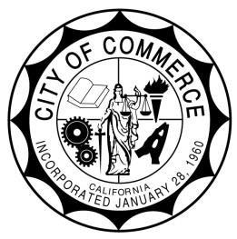
CITY OF COMMERCE
AGENDA REPORT

TO: Honorable City Council

FROM: City Manager

SUBJECT: Approve and Adopt a First Amendment to the Agreement for General Legal Services with Olivarez Madruga Law Organization

MEETING DATE: August 26, 2025

RECOMMENDATION:

It is recommended that the City Council consider approving the attached First Amendment to the Agreement for General Legal Services with Olivarez Madruga Law Organization adjusting rates for legal services.

BACKGROUND/ANALYSIS:

The City Council retained the law firm of Olivarez Madruga Law Organization (“OMLO”) pursuant to an Agreement for General Legal Services with OMLO (“Agreement”) on October 17, 2017.

OMLO has provided excellent legal services and support to the City, its staff and community members, primarily providing support to the Human Resources Department.

FISCAL IMPACT

The adopted 2025/2026 fiscal year budget includes resources for these services.

RELATIONSHIP TO STRATEGIC GOALS:

This staff report relates to strategic goal of Fiscal Sustainability, Guiding Principle 3: Implement a compensation philosophy that allows the City to proactively compete for and retain top qualified personnel.

CONCLUSION

By approving this proposed First Amendment the adjustment in legal service rates would be memorialized as reflected in the attached amendment.

Respectfully submitted: Ernie Hernandez, City Manager

Attachments:
- First Amendment to Agreement with OMLO

